Thinking Independently in the Age of AI
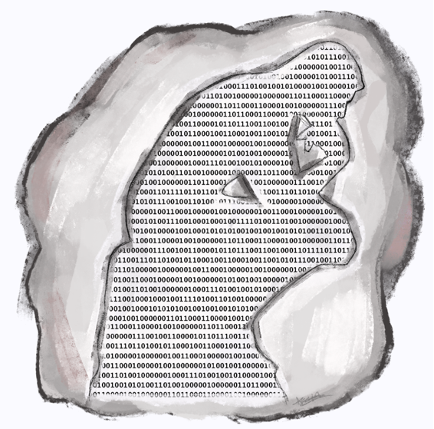
Avery Huffer for The AntReader
In 2016, high-profile physicist Stephen Hawking said, “Success in creating AI could be the biggest event in the history of our civilization, but it could also be the last — unless we learn how to avoid the risks.”
Since then, the capabilities of Artificial Intelligence have surged exponentially, heralding a transformative era fraught with potential peril. As an opinion essay from The New York Times (NYT) puts it, “[AI] makes us live in both optimism and concern. Optimism because intelligence is how we solve problems. Concern because that same intelligence will degrade our science and debase our ethics by incorporating a flawed conception of thinking into technology.” However, I contend that the dichotomy of optimism and concern oversimplifies the complex landscape of AI's impact. Rather, I advocate for a nuanced perspective that acknowledges both its promise and peril.
To someone using AI systems as a tool, they can seem like magic. A calculator, for instance, is used in almost every STEM class and provides all the results one needs, so it is rarely ever considered exactly how it does so. Similarly, AI gives users results without hesitation, benefitting academic and personal lives, but if we zoom into specifics, the picture dissolves into computational static. ChatGPT, a free, open-source AI chatbot, can write papers. Replika gives people a digital companion, something vital in the age of loneliness. While productive, these also exacerbate the pitfalls of society we cannot help but create. Writers are not critically thinking and people think they can find peace in loneliness through a virtual companion. The accessibility of easy solutions can often make them more appealing as an escape from problems or sources of solace.
Currently, AI is hitting the market with incredible speed and very little governance. Major tech companies and countries are in a race for AI dominance. Money is gushing towards companies with AI expertise. AI continues to blow past us in benchmark after benchmark of higher cognition. If one company slows down, another is going to speed up. If one country hits pause, the other is going to push harder. There is this natural pace to human deliberation and a lot of breaks in our society when we are denied the luxury of time. Fatalism becomes the handmaiden of inevitability and inevitability becomes the justification for acceleration.
Paul Christiano, a pivotal figure at OpenAI who later founded the Alignment Research Center, which works on theoretical AI alignment and evaluations of machine learning models, wrote about how people tend to overestimate the time it will take for AI systems to drastically transform the world. Christiano clarifies his argument by saying that when AI systems reach a level of power where they can improve themselves, the potential for rapid and unimaginable growth becomes significant, highlighting the importance of understanding and managing this acceleration. Nowadays, we do not have the luxury of responding slowly to technologies; at least not if it keeps advancing at this rate.
A 2022 Expert Survey on Progress in AI by AI Impacts reveals how those responsible for building systems in AI feel about the product they are creating. One of the questions asks about the likelihood of humans losing control over advanced AI, leading to extinction or severe disempowerment. The median reply was 10%. For individuals actively engaged in shaping this new era of intelligence, such a figure should give rise to profound unease, if not outright alarm.
Recent developments and warnings underscore the gravity of the situation. In May 2023, a consortium of prominent figures in AI issued an open letter cautioning against the existential threats posed by AI emphasizing the need to prioritize the mitigation of AI-related risks alongside other global perils like pandemics and nuclear warfare. While contemporary AI systems may seem far from capable of catastrophic outcomes, the trajectory of advancement raises legitimate concerns about the future.
However, modern AI is predominantly machine learning, not true intelligence. The “thinking,” for lack of a better word, these machines do are utterly inhuman, but we have trained them to learn and become increasingly humanlike. As the NYT essay mentioned earlier puts it, “[AI tools] are constitutionally unable to balance creativity with constraint. They either overgenerate (producing both truths and falsehoods, endorsing ethical and unethical decisions alike) or undergenerate (exhibiting noncommitment to any decisions and indifference to consequences).”
AI has the potential to help us create more equitable systems. It is an opportunity, not a threat. They take huge amounts of data, search for patterns in it, and become increasingly proficient at generating statistically probable outputs. The threat was always us humans. For example, in 2016, Microsoft’s Tay chatbot, a precursor to ChatGPT, flooded the internet with misogynistic and racist content, having been polluted by online trolls who filled it with offensive training data. Microsoft reflects on that moment saying, “Unfortunately, in the first 24 hours of coming online, a coordinated attack by a subset of people exploited a vulnerability in Tay.”
Think about growing up. Every human you’ve interacted with, the insensitive jokes, the bad takes, the racist ideologies. But the counter for you as a human is that you're not fully logical-based. You also have the element of emotion. Humans learn to live together and we hope not to be racist, misogynist, or homophobic. AI will never evolve in that way. In part because that requires consciousness. And we just don’t know how to code consciousness. Human intelligence is also capable of moral thinking. This means constraining the otherwise limitless creativity of our minds with a set of ethical principles that determines what ought and ought not to be.
Brian Ngo is an Opinion Intern for the winter 2024 quarter. He can be reached at bpngo2@uci.edu
Edited by Trista Lara, Annabelle Aguirre, and Laiyla Santillan

